LOURDES MATHA COLLEGE OF SCIENCE AND TECHNOLOGY
DEPARTMENT OF COMPUTER APPLICATIONS
Semester: 3rd Branch: MCA Admission Year: 2021

First Series Examination / October 2022
Time: 1 1/2 Hour 20MCA203 /Design & Analysis of Algorithms Max. Marks: 30
Q.No. | PART-A (Answer ALL) | Marks | CO | BL
1 | Define algorithm. Explain its characteristics. | 3 | CO1 | K1
2 | Write note on time & Space Complexities. | 3 | CO1 | K1
3 | Describe the control abstraction for divide and conquer method. | 3 | CO2 | K2
4 | Explain the control abstraction for greedy strategy. | 3 | CO3 | K2
5 | What is a minimum spanning tree? | 3 | CO1 | K1
6 | Write note on Job Sequencing problem. | 3 | CO1 | K1
PART-B(Answer any TWO)
7 | Write the algorithm for Quick Sort and sort the elements  50,30, 80,5,90 using it. | 6 | CO2 | K3
8 | Determine the optimal solution for the following 3 items (P1, P2, P3) = (500,900,700) and (W1, W2, W3) = (1, 3, 7). Knapsack capacity is 5. Also write down the Knap sack algorithm. | 6 | CO3 | K4
9 | Apply Prim’s Algorithm to find minimum spanning tree for the given graph.  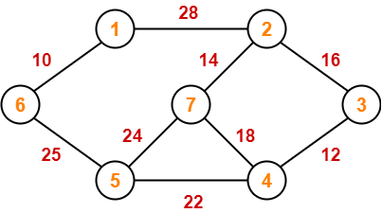 | 6 | CO3 | K5

